**General Definition Document**

**Grupo AXO**



**May 2016**

**e-commerce**

Table of contents

E-COMMERCE CONCEPTS 4

BUSINESS RULES 4

MARKETING 6

SEO Strategy 6

Basic SEO, statistics and reports 6

CUSTOMER CARE 7

Help Desk 7

Call Center 7

Ticket system 7

Chat 7

Contact us 7

Customer tools 7

SALES FLOW 8

Online Flow 8

Offline Flow 9

Payment on delivery 9

PLATFORMS AND DEVICES 10

CORPORATE CONTENT (STATIC) 11

TRANSACTIONAL MESSAGING (EMAIL) 12

INTEGRATIONS 13

Payment Methods 14

Paymet Gateway 14

Payment Tokenization 14

Fraud Management Solutions 16

Third party payment gateways 17

Integration with the ERP 17

Shipping carrier integration 18

WMS CEDI’s 18

Google Analytics 18

CATALOG 18

NAVIGATION AND DESIGN 21

Express navigation and design 21

# E-COMMERCE CONCEPTS

In order to achieve a higher quality and ensure optimal user experience for every kind of person, regardless of the technology they use or their experience on the Internet, we develop the entire project with the following concepts:

* **SEO Strategy**: Optimize the store to be indexed by search engines and drive traffic without paying.
* **Accessibility**: The user should be able to view the site and have the same experience regardless of the web browser or device used to visit the store.
* **Navigation and architecture**: Organize the information optimally for it to be easily found on the site with an intuitive and simple navigation.
* **Standardization and Security**: We follow the best practices and guidelines of the W3C and the web governing standardization consortia.
* **Responsive Design**: The store’s design will adapt to any screen resolution and different devices.

# BUSINESS RULES

The business rules applied to the e-commerce stores where defined as a result of a series of workshops. These rules allow the standardization of the order management and help facilitate the implementation of a uniform logistics system.

**Shipping**

There will be 2 shipping options for orders:

* **Express Shipping**: Faster shipping method that will deliver the merchandise in 1 to 3 business days, this method will have a fixed price regardless of the quantity of the products purchased, the shipping address (within Mexico) and type of order.
* **Normal Shipping**: This shipping method will take from 4 to 7 business days to deliver the product and it will be free of charge if the customer’s bill matches or exceeds $899 Mexican pesos.

**Cancelations**

All cancelations will be free of charge to the customer, but the cancelation process must be registered via the clients account on the online store. All cancelations must be made before the order is shipped, the customer can cancel his order only when his order status is: payment pending, paid or building order. If the order has the status sent or delivered the customer must refer to the return or exchange process.

**Returns/Exchanges**

All returns and exchanges must be handled according to the next rules:

* **Return/exchange time**: 15 days after the purchase is made
* **Return/exchange process**: The customer must request the return/exchange via his account in the store and explain the reasons of his return/exchange. After doing so, the system will allow him to print the shipping carrier’s prepaid tracking code and finally take the package to the shipping provider.
* **Conditions**: The merchandise must comply with Grupo AXO’s established return policies. The policies will be available for the customer to review in every site (corporative content and product detail).

It’s important to mention that in Grupo AXO’s return and exchange policy there are certain products that are no eligible for return or exchanges.

In this phase of the project returning or exchanging a product in a physical store will not apply for technical reasons.

* **Return/exchange cost**: Free of charge to the customer one time per order. If the customer returns the merchandise for a second time a $100 pesos amount will be charged, the amount can be configured on the backend.
* **Money return**: We will refund money via coupons and if requested in the same credit / debit card of the initial payment
* 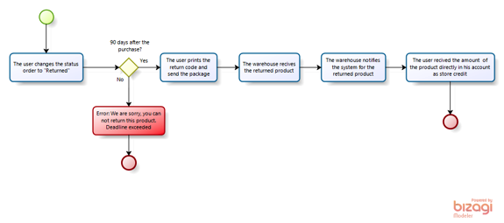

**Invoicing**

The customer will have the possibility to invoice any of his e-commerce orders.

# MARKETING

## SEO Strategy

During the course of the project the keywords list provided by the brand’s marketing area will be used to create a customized SEO strategy to optimize the store for organic search engine positioning. The goal is to locate the URLs in the top results of search engines.

Provide a SEO optimization report at the closing point of the project.

### Basic SEO, statistics and reports

A series of activities and deliverables to guarantee that the advanced configurations made to the site remain working correctly and therefore the ranking keeps increasing in an organic way.

# CUSTOMER CARE

Grupo AXO will implement a customer care center with activities like: help desk, call center, chat assistance and service tickets tools, among others. The following definition of responsibility illustrates the system functionalities offered by the platform and integrations necessary to have a functional customer care area for e e-commerce.

## Help Desk

### Call Center

The customer care number will be displayed in the footer and relevant screens of the site.

### Ticket system

Integration of the e-commerce platform with a customer service tickets system.

This tool allows the customer care area of the e-commerce business to give the proper follow up to all issues raised by customers.

### Chat

There will be a chat box displayed on the check out process, to help customers complete their transactions

### Contact us

The platform’s generic contact form will be linked with the ticketing system to ensure a proper tracking of all the incidents.

## Customer tools

|  |  |
| --- | --- |
| **Customer** | |
| Type | Detail |
| Dashboard | Displays a summary of the most relevant information of the user’s account. |
| Account Information | Displays detailed information of the user’s account. |
| Address Book | Displays the shipping and billing addresses registered by the customer. |
| My orders | Displays the customer ’s order history and order status. |
| Subscribe/Unsubscribe to the newsletter | Allows the user to select whether or not to receive the store’s newsletter. |
| My returns | In this section the user can view and manage the history of his returned orders. |
| Password recovery | Allows the customer to recover his login password if forgotten. |

# SALES FLOW

The project proposes the use of three different sales flows corresponding to the three ways in which the user can make a payment (credit / debit card, referenced payment and payment on delivery).

### Online Flow

The online sales flow is the process in which an order is placed by a customer having chosen a payment method as credit / debit card or a third party payment gateway (PayPal).

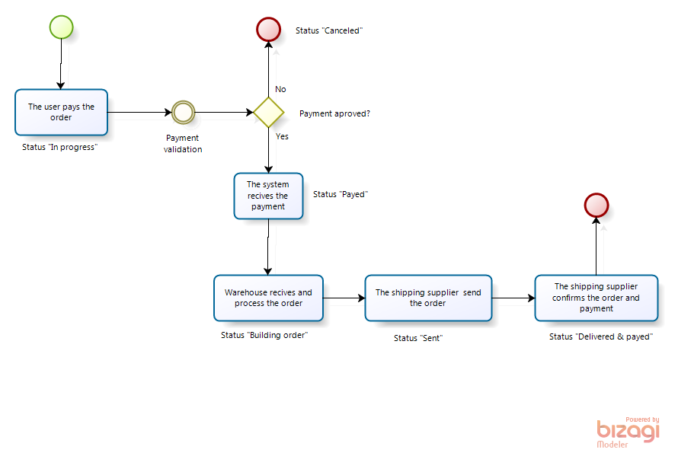

### Offline Flow

The offline sales flow is the process in which an order is placed by a customer having chosen as a payment method a referenced payment (bank, convenience stores, drugstores, etc.)

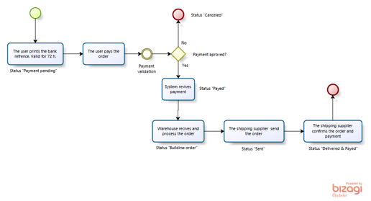

### Payment on delivery

The payment on delivery sales flow is the process in which a customer having chosen as a payment method, a payment on delivery, places an order. In this case Axo sends the merchandise to the customer and the customer pays the order to the shipping supplier upon delivery.

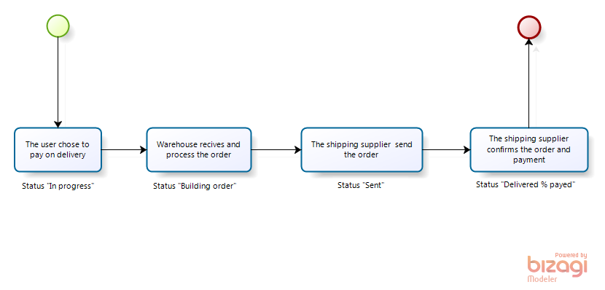

# PLATFORMS AND DEVICES

[Responsive Web Design](http://mobiledevices.about.com/od/additionalresources/a/Responsive-Web-Design-For-Mobile-An-Introduction.htm) or RWD as it is commonly referred to, implies the formatting of Website design in a way that it’s most optimal for viewing and navigating across a wide range of devices, including traditional PCs, smartphones and tablet devices.

An RWD makes use of media queries, which enable the page to employ different CSS3 style rules; plus fluid grids and flexible images, so that the Website automatically adjusts itself for a variety of mobile devices and their screens.

The project contemplates the use of a responsive design to assure a correct visualization of the store in any device the customer decides to visit. This design will adjust the store to any screen size the customer chooses (Tablet, smartphones, PC and big screens).

The image below explains graphically how the responsive design works:

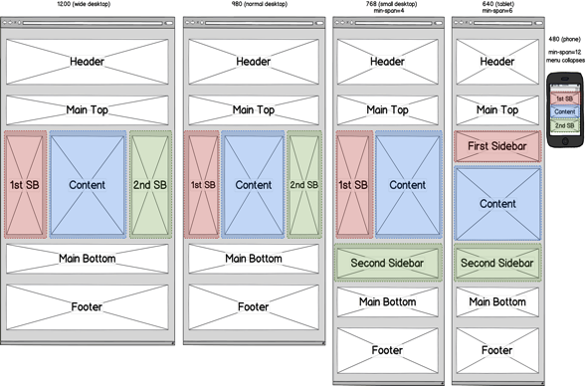



The project guarantees a full performance with any of the latest versions of the following web browsers:

* Explorer
* Chrome
* Firefox
* Safari

## Mobile App

Mobile app is not consider in this project

# 

# CORPORATE CONTENT (STATIC)

The corporate content is included in all the sections of the store in which the type of content is static. Generally these sections can be found on the footer of every page and they contain corporate information (About us, careers, contact us, etc.)

For this project it was decided to have static content sections. Each store will have all the sections deemed necessary.

The corporate content will be a direct translation of all the existing content in the flagship’s store.

|  |  |
| --- | --- |
| **Corporate sections** | |
| Store Locator | About Ads |
| Customer Service number | Privacy Policy |
| Help | Site Map |
| Return Policy | Copy rights |
| Contact Us | Newsletter |
| About Express: Who we are |  |
| Terms & Conditions |  |

Payment method logo (Visa, Master card, PayPal, MercadoPago)

Security compliance seals (Amipci, SSL Verisign, Symantec)

Social media (Facebook, Twitter, Instagram)

Additional to these sections some other static content pages must be created to fulfill the needs of the multiband store Epica. These sections are explained below.

# TRANSACTIONAL MESSAGING (EMAIL)

On any project the communication between the system and the client is necessary. Such interactions are reflected in a series of transactional emails that inform the user about system changes or to confirm a request to the system by the user.

The following table shows the list of transactional emails to be used in this project:

|  |  |  |  |  |  |  |
| --- | --- | --- | --- | --- | --- | --- |
| **Transactional emails** | | | | | | |
| Description | Notifications type | | | | Delivery method | |
|  | Customer profile (user account) | Purchase order | Promos | Confirmations | E-mail | Page |
| Site sign in | x |  |  | x | x |  |
| Account activation confirmation | x |  |  |  | x |  |
| Password reset |  |  |  | x | x |  |
| New password |  |  |  | x | x |  |
| Product share |  |  |  | x |  | x |
| Shared wish list |  |  |  | x |  | x |
| Newsletter subscription | x |  |  | x | x | x |
| Unsubscribe to newsletter | x |  |  | x | x | x |
| Order confirmation | x | x |  | x | x | x |
| Shipping confirmation | x | x |  | x | x | x |
| Order status update | x | x |  | x | x | x |
| Delivery confirmation | x | x |  | x | x | x |
| Invoicing confirmation | x | x |  | x | x | x |
| Bank cards changes | x |  |  | x | x | x |
| Changes on shipping address | x |  |  | x | x | x |
| Coupon or/and discount code alert |  |  | x | x | x | x |
| Contact request notice |  |  |  | x | x |  |
| RMA (Return Merchandise Authorization) Confirmation | x | x |  | x | x | x |

# INTEGRATIONS

The document states a series of necessary integrations to provide a correct communication between businesses.

The following diagram shows the flow of the integrations:

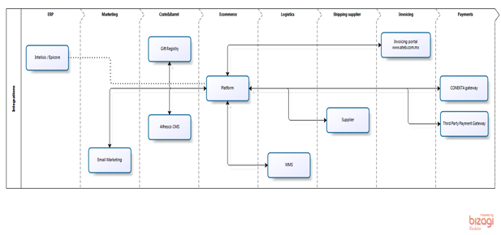

## Payment Methods

The store will be capable of processing a wide variety of payments methods so the client can choose the more convenient option to complete their purchase. The available payment methods are:

* Credit cards
  + Visa
  + Master Card
  + American Express
* Debit cards
  + Visa
  + Master Card
* Referenced Bank Deposits (Banorte)
* Convenience store payments
* PayPal
* Cash on delivery

## Payment Gateway

The store will be integrated with our payments gateway. This gateway includes the credit/debit (Visa, Master Card), referenced deposit and convenience store payments. The use of this engine allows the use of credit and debit card information as it’s aligned with the PCI and DSS compliance.

## Payment Tokenization

Eliminating payment data from your network is the only way to ensure that your customer's sensitive personal information isn't compromised during a security breach and is a much more cost efficient solution than having PCI compliance.

**Tokenization Defined**

Tokenization is the replacement of sensitive data with a unique identifier that cannot be mathematically reversed. In your environment, tokens take the place of sensitive credit card data. Typically, the token will retain the last four digits of the card as a means of accurately matching the token to the payment card owner. The remaining numbers are generated using proprietary tokenization algorithms.

**How It Works**

* To make a purchase on your website, the customer will enter their payment card information into the designated payment fields on the order page. These payment fields will be hosted by the payment gateway using [Secure Acceptance](http://www.cybersource.com/products_and_services/payment_security/secure_acceptance/). When the customer hits the 'submit' button, the data is immediately encrypted and transmitted directly to Conekta for storing, processing, and token generation. The payment data never enters your environment.
* The encrypted primary account number (PAN) is decrypted when it enters Conekta’s Level 1, PCI-compliant data vault, where it is securely stored. The payment data is then passed on to the processing channel (bank) and returned to Conekta with an accepted or denied result.
* Payment Gateway returns the result to you but substitutes the PAN data with a uniquely generated token. You store the token in your database of record system (such as ERP system) for future transactions or chargeback resolution on that account. Customer service representatives can easily verify customers as the custom token will retain the last four digits of the original PAN.

**Benefits of Tokenization**

* Reduces PCI DSS Scope
* Renders payment card data meaningless to hackers
* Chargebacks and payment reconciliation can take place without handling payment data
* Not mathematically reversible
* Format fits legacy payment card data fields
* Integrates with Account Updater to automatically update payment data for fewer failures

Payment gateway also provides tokenization services that store the credit card information of the customers so that they can load this information for further transactions.

## Fraud Management Solutions

Payment gateway includes the antifraud system that detects fraudulent activity; this is an elemental system for an e-commerce store. The system reduces fraud risks and counter charges at the same time that offer a better and more powerful shopping experience for the customers.

Fraud Management Solutions help’s you to:

* Minimize fraud loss by stopping fraud loss closer to it’s inception
* Ensure a positive customer experience by detecting good orders quickly
* Minimize your operating costs by reducing manual review and tuning fraud processes quickly

**Global Fraud Management Portal: Decision Manager**

The portal, Decision Manager, includes the world's largest fraud detection radar, enabling you to get more data about your inbound order, as well as compare it to data generated from the over 60 BILLION transactions processed annually – including truth data. It comes with a business-user rule management console to access over 260 popular global validation tests and services, a highly customizable case management system, and reporting and analytics to provide greater visibility over the fraud management process.

**Managed Risk Services**

Combines the Decision Manager portal with the services of expert personnel to assist your fraud management operation. We work with you to define your requirements, then design and implement a solution tailored to meet your business goals. You can even outsource your full fraud management operations to us, if desired.

**Payer Authentication**

Provides the online payment guarantees offered by the Verified by Visa and MasterCard SecureCode schemes via a single connection. These programs verify the cardholder's identity with the card issuer in real-time to help reduce the risk of fraud.

**Verification and Compliance**

Provides verification and compliance services that allow businesses to verify specific customer data during non-face-to-face transactions, utilize additional data points for fraud detection, and comply with government policies and tax laws.

## Third party payment gateways

In addition to the integration with payment gateway we will integrate PayPal

## Integration with the ERP

The project contemplates an integration with Grupo AXO’s ERP to meet the requirements of the accounting and finance areas and thus comply with the fiscal legislation of the country. The integration ensures transmission of detailed information of the orders made ​​in the portal.

The following concepts will be managed from the ERP:

* Item Master
* Product transfers from general warehouse to e-commerce warehouse
* Store inventory
* E-commerce orders and sales
* RMAs

## Shipping carrier integration

## The project contemplates an integration of the platform with shipping carriers. This integration will allow the customer to consult his order status trough a tracking number after the product is handed to the shipping carrier. All this actions can be made without leaving the online store.

## **WMS CEDI’s**

The platform will be integrated to the distribution center WMS from the e-commerce warehouse. As a result of the workshops held with the logistics experts we came to the conclusion that the stock and inventories will be synchronized each 10 minutes. The WMS will be responsible for consuming the platform’s web service API.

## **Google Analytics**

The store will be integrated with Google Analytics this will give management the possibility to consult and analyze all the information regarding the store’s activities, thus allowing management to take more informed decisions about the store’s optimization and performance improvement every month.

# CATALOG

List of elements used in the catalog (the use of these elements are visually described in the next section “navigation and design”:

|  |  |
| --- | --- |
| **Product List** | |
| Requirement | Description |
| Top banner for category | This is a space at the top of the category to place some slider of static banner. |
| Search platform | An advanced search platform will be integrated to the store. This search platform helps the customer to have better results in any search he performs, the features that allow this are:   * Autocomplete * Synonyms * Search suggestions * Related terms   http://lucene.apache.org/solr/ |
| Infinite Scrolling | This is a feature that provides the user the ability to keep scrolling down. When the products of the current category are finished the next category will be shown. |
| Order by | This feature let the user to sort the results by: price, arrivals and other attributes. |
| Views | This feature offers the possibility to display the results grid in different views (3 in a row, 4 un a row, etc.) |
| Color Swatch | This is a palette showing the available color for the selected product. |
| Filters | The user will be able to filter all his results so he can have an easier time searching for the product he wants. |
|  |  |
| Elements for each product | |
| Photo | The product picture |
| Name | The product name |
| Price | The product price |
| Special price | The product special price |
| Graphic labels | Graphical labels such as new, sale, store only, 50% discount, etc. |
| Filters | |
| Color | The user can filter the results by color |
| Size | The user can filter the results by size |
| Category | The user can filter the results by category |
| Price | The user can filter the results by price |
| Collection | The user can filter the results by collections |
| Sale | The user can filter the results by products on sale |

|  |  |
| --- | --- |
| **Product detail** | |
| Requirement | Description |
| Breadcrumbs | It allows users to keep track of their locations within the store. |
| Name | Displays the product name. |
| Description | Displays a short description provided by Grupo AXO. |
| Style Code | Display the unique style code of each product. |
| SKU (hidden ) | This is the SKU unique number. It will be hidden on the frontend. |
| Care & Fit | This text explains to the user how to take care of the product. |
| Shipping Policy, Return exchange and cancellation. | These are the shipping, return, exchange and cancellation policies for the whole store. |
| Price | The product price. |
| Special Price | The product special price. |
| Brand logo | Show the brand/collection logo. |
| Color Swatch | This is a palette showing the available color for the selected product. |
| Size (as a mosaic) | Show the available sizes for the selected product. |
| Store directory | This is a link to the store directory. |
| Zoom | Add zoom to the main product image. |
| Images and thumbnails | Displays a carrousel of images featuring the selected product. |
| Sizes chart | A link to see the whole sizes chart. |
| Inventory alert (when out of stock) | This feature allows users to subscribe to an inventory alert when the selected product is out of stock. |
| Graphic labels | Graphic labels are displayed to communicate new arrivals or products in sale. |
| Add to favorites | This button allows users to add the selected product to their favorites. |
| Add to bag | This button adds the selected product to the shopper’s bag. |
| Quantity | This is an input or dropdown menu to select how many products should be added to the bag. |
| Sharing Toolbar | This feature enables the possibility to share content in social media networks or email. |
| Related products | This section shows some related products to the user. |
| Suggested products | This section shows some suggested products to the user. |
| Recently viewed | This section shows the products recently viewed by the user. |

# NAVIGATION AND DESIGN

To ensure the best user experience and usability of an e-commerce it is necessary to categorize the catalog featured on Express.com.mx. Express navigation and design

The categorization of the store will be aligned with the site map sent by Express’s. Minor changes can be accepted.

The navigation, design and functionality are described on the pictures below.

**Home**

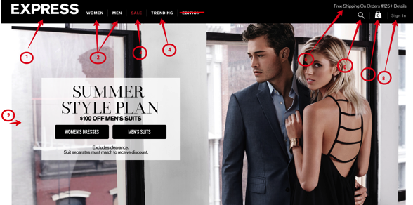

1. Express logo
2. Product categories
3. Sale category
4. Trending (special) category
5. Promotional label
6. Search
7. Shopping bag
8. Sign in
9. Carrousel (main banner)

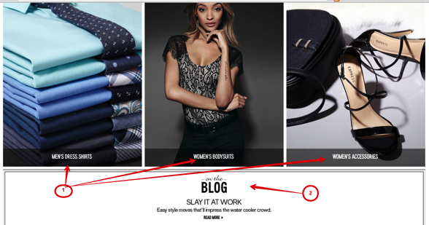

1. Home categories banners
2. Blog?

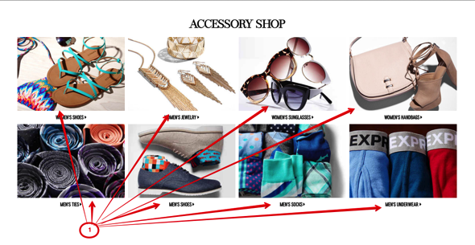

1. Accessory category banner

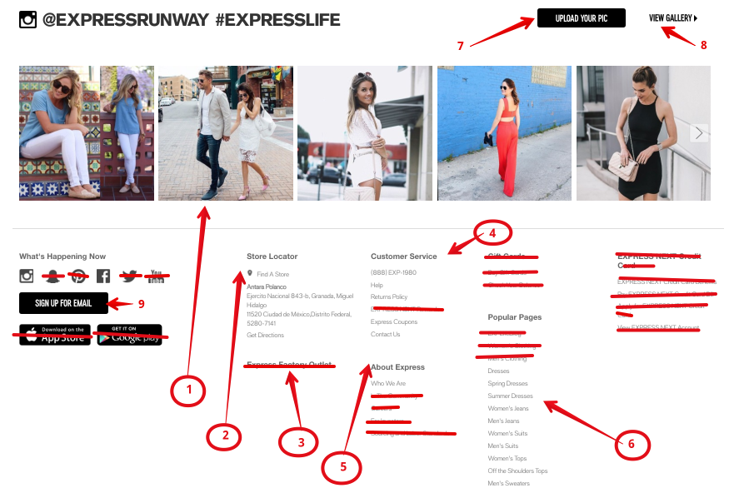

1. Mexico’s social networks content and link
2. Store locator
3. Express factory Outlet (Not in Mexico)
4. Customer service
5. About Express
6. Popular pages (subcategories links)
7. Upload your pick (TBD in analysis)
8. View Gallery

**Footer**

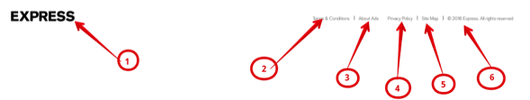

1. Express logo
2. Terms and conditions
3. About us
4. Privacy policy
5. Site map
6. Copy rights

**Menus**

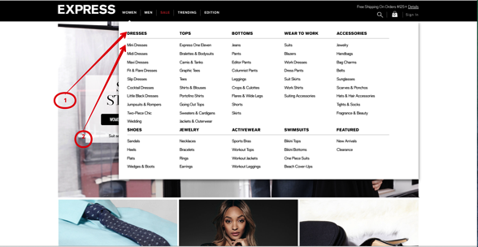

1. Subcategories for Mexico
2. Sub subcategories for Mexico

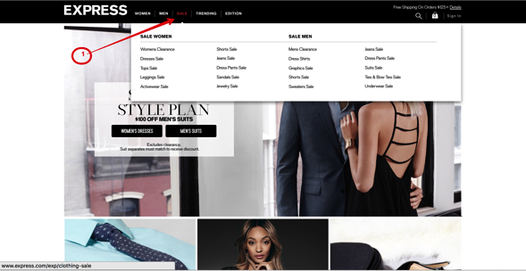

1. Red color for Sale menu

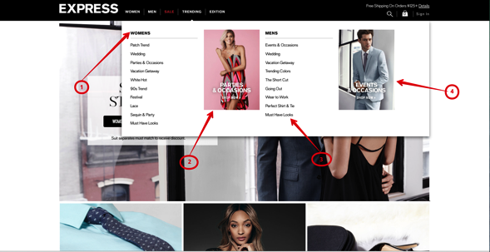

1. Women’s trending menu
2. Women’s thumbnail
3. Men’s trending menu
4. Men’s thumbnail

**PRODUCT LIST**

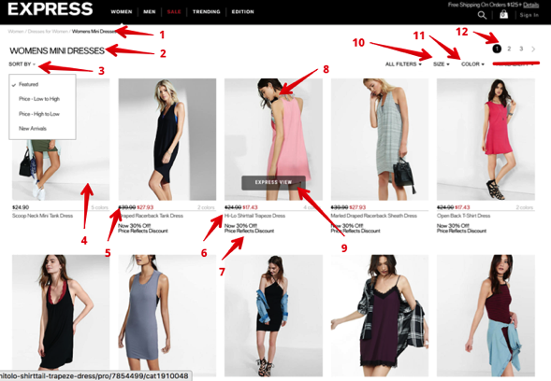

1. Breadcrumbs
2. Sub subcategory name
3. Sort
4. Product photo
5. Regular and discount price
6. Product name
7. Discount description
8. Alternative view with mouse over
9. Express view label with mouse over
10. Size filter
11. Color filter
12. Paging

* No availability filter

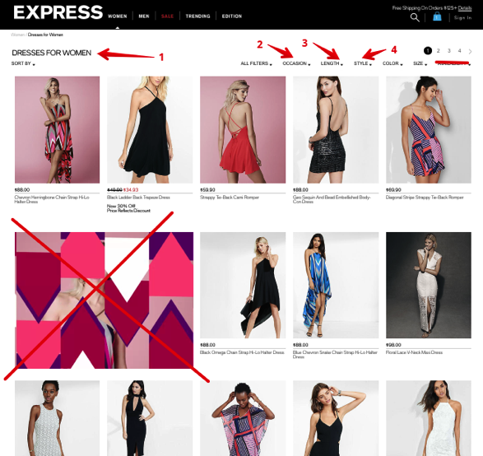

1. Subcategory name
2. Occasion filter
3. Length filter
4. Style filter

* No availability filter
* No videos

**EXPRESS VIEW**

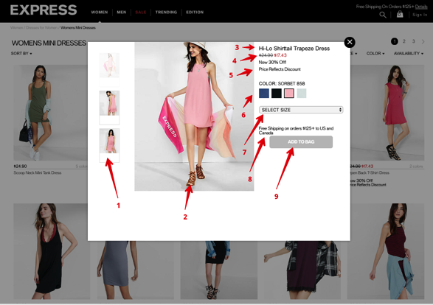

1. Alternative views
2. Product photo
3. Product name
4. Regular and discount price
5. Discount description
6. Color name and alternative colors
7. Size selector
8. Shipping information
9. Add to bag button

**PRODUCT DETAIL**

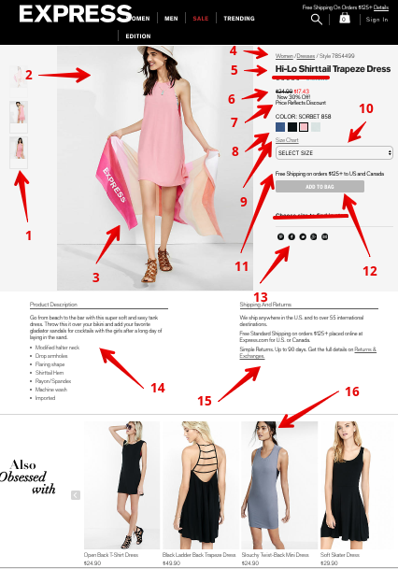

1. Alternative views
2. Product photo
3. Zoom
4. Product breadcrumbs
5. Product name
6. Regular and discount price
7. Discount description
8. Color name and alternative colors
9. Size chart
10. Size selector
11. Shipping information
12. Add to bag button
13. Share in social networks
14. Product description
15. Shipping and returns information
16. Product suggestions

* No reviews
* No select size to find in stores

**Shopping bag and check out**

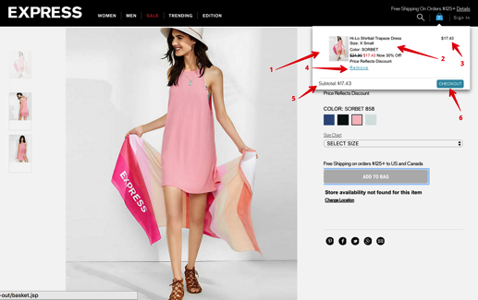

1. Shopping bag mouse over effect
2. Product and price information
3. Net Price
4. Remove function
5. Subtotal function
6. Checkout button

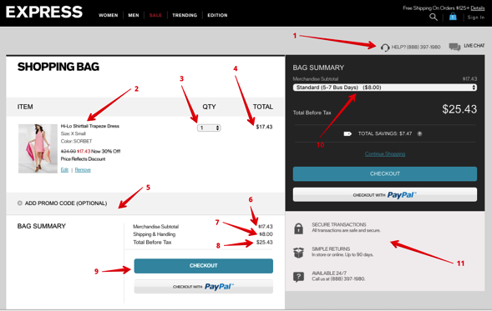

1. Call center number and chat functionality
2. Product info and photo
3. Quantity functionality
4. Net price
5. Add promo code functionality
6. Merchandise total
7. Shipping and handling cost
8. Total
9. Checkout button
10. Delivery method
11. Checkout relevant information